

**KULLIYYAH OF INFORMATION & COMMUNICATION TECHNOLOGY**

**CSCI3302**

**SEMESTER 1, 2022/2023**

**SECTION 02**

**INDIVIDUAL SIMPLE PROJECT REPORT**

**PREPARED BY: [INDIVIDUAL/GROUP NAME]**

|  |  |
| --- | --- |
| **NAME** | **MATRIC NO.** |
| MUHAMMAD YUSOFF JAMALUDDIN | 2016799 |

**LECTURER**

MADAM NURUL LIYANA BINTI MOHAMAD ZULKIFLI

SIMPLE PROJECT REPORT

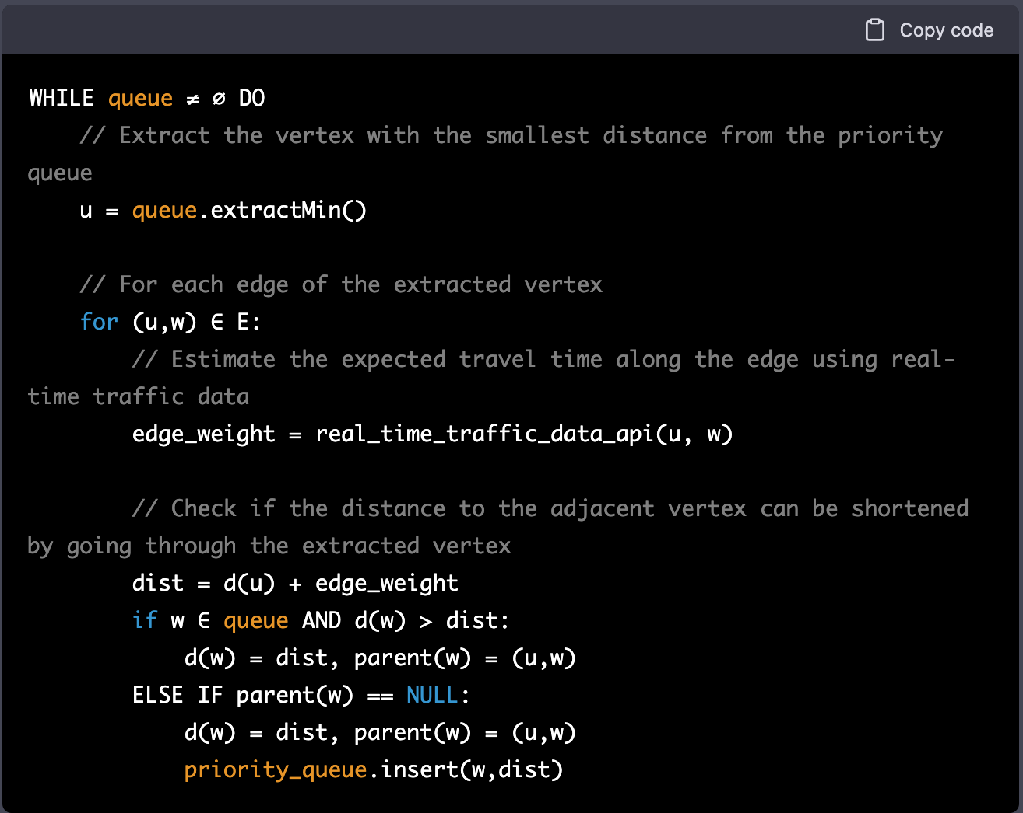

Figure Modified code we use in our discussion for the report

From our group discussion, we agree to use the Dijkstra instead of the other algorithm. The modified code also easier to understand as we all have the basic understanding of the algorithm itself.

In this modification, we add the real-time traffic as our priority options. Previous code only prioritizes the distance between the user and the destination and not include real-time traffic in their algorithm. This can cause the distance is short but the traffic is bad.